Topic | Knowledge - Children will learn | Children will be able to… | Prior Knowledge
Introduction/ travel | Setup/ put away gymnastic equipment safely.  Travel across a mat | - Get out and put equipment away safely  4 children to carry a mat (each corner).  4 children to carry bench (1 on each end and 2 in middle facing each other)  - Children can travel across a mat using a variety of different ways including the correct start and end position.  Children to travel across the mat in the following ways:  - Tip toes  - Jumping – 2 feet to 2 feet, 2 feet to 1 foot, 1 foot to 1 foot  - Spinning  Strong emphasis on balance and control | Understanding of what a bench/ mat is  Travelling across a mat  Body parts lesson with an understanding of what tip toes mean.
Rolls | Children will learn a range of rolls. | - Children to perform a range of rolls including forward, pencil, tuck (egg), straddle (teddy bear).  Forward - Chin tucked in. hands flat on mat. Walk over into roll (beginners). Knees bent, push over for roll  https://www.youtube.com/watch?v=_9HxqFzHAT4  Pencil –Lie on a flat mat with your arms stretched straight over your head and feet stretched away from your body. Roll to in one direction ensuring that the tummy, legs and muscles are squeezed together. Complete a number of rolls until reaching the end of the mat.  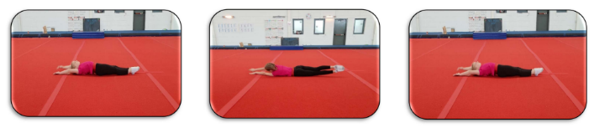  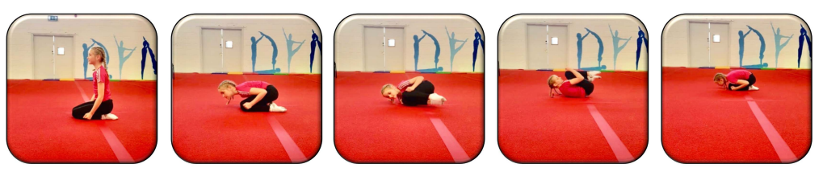  Tuck – Kneel on the floor, tuck your knees into your chest and hold your arms tightly to the side of your body. Keep your chin tucked in and shoulders just off the floor. Complete a 360 degree rotation completing a full roll of the body.  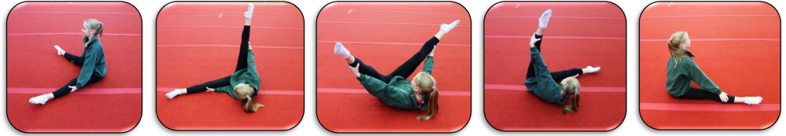  Straddle – Sit on the floor with your legs straight and spread apart. Sitting tall, place your hands behind your knees. Lean to the left bringing the right leg up to start the rolling action. Roll sideways across your back and shoulder finishing back in the straddle position in the opposite direction to where you started. Repeat the roll until you have made a full circle. | EY- Types of rolls taught are egg roll, teddy bear roll, dish roll and rock on back  KS1- Rolling across the mat, pencil and forward roll.
Jumps | Children will learn a range of jumps. | 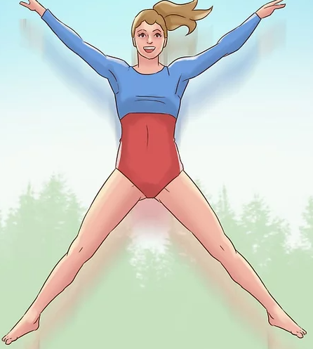  - Children to jump from a bench/ height and show control on landing. Children will recap the jumps taught in KS1 and then focus on 4 new jumps.  - Star jump – stand with legs shoulder width apart and knees slightly bent. Squat down bending the knees and jump vertically as high as possible. At the same time, bring the arms and legs up to point out wide creating the ‘star’ shape. On the descent, bring the arms and legs back in and land with the knees bent.  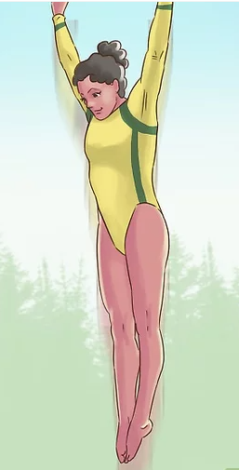  - Straight jump – stand in the straight body position keeping the legs together and arms by the side. Jump straight up and as you enter mid-air, point the toes and extend the arms up past the head pointing fingers. Land in plié position.  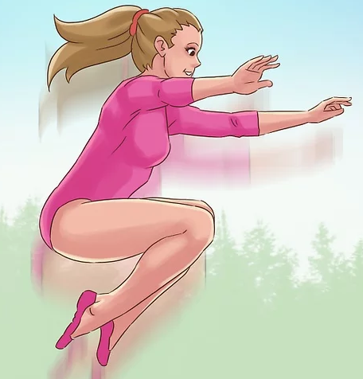  - Tuck jump – stand with feet shoulder width apart keeping the knees slightly bent. Ensure the head is up and eyes facing forward. From the squat position, push up as powerfully as possible and as you reach mid-air, bring the knees into the chest. Bring the arms around to clasp the knees and on decent, let go of the knees and bend on landing.  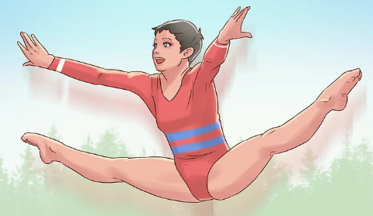  - Straddle jump – To take off, use the strength in your legs to get as high as possible. Bring your legs out and point the toes when in mid-air. Arms should also be stretched out towards the pointed toes (try and touch if possible) keeping the head up with eyes facing forward. On decent, quickly pull the legs back together and bend knees on landing.
Supported routine | Children will learn how to mirror a given routine. | - Children will mirror a basic routine including traveling across a mat, rolling and jumping from a bench with control of their body.  Children to complete MTYT in learning a basic routine. Children to be able to name each movement that they are completing. The routine will include:  - Start position  - Two ways of travelling across the mat  - Two rolls  - Two jumps  - End position | Start/ end position, travelling, rolls, jumps.
Independent routine | Children to create their own routine | - Children to create their own gymnastics routine including: start/ end position, travels, rolls and jumps.  Children to be given time to plan their own routine which must include:  - Start position  - Two ways of travelling across the mat  - Two rolls  - Two jumps  - End position  Children to perform their routine whilst being able to explain the name of each element. | Start/ end position, travelling, rolls, jumps.  Supported routine in previous lesson.

Keywords
Early Years (Prior learning) |  | Year 1 and 2 (prior learning) |  |  |  |  |  | Year 3 and 4 Key words
move | travel | control | travel | start position | level | tuck | elegant |  | tuck jump | technique
copy | over | hold | forward roll | end position | direction | star | extension |  | straddle jump | explore
forwards | space | sequence | jump | apparatus | sequence | pike | pointed toes |  | straight jump | create
backwards | rock | strength | safely | equipment | pathway | straddle | graceful |  | star jump | contrasting
sideways | shape | balance | perform | mat | link | speed | pointed fingers |  | forward | quality
egg roll | teddy bear roll | support | routine | bench |  |  | pressure |  | Pencil | apparatus
dish roll | rock on back

