Topic | Knowledge - Children will learn | Children will be able to… | Prior Knowledge
Introduction/ travel | Setup/ put away gymnastic equipment safely.  Travel across a mat, bench and beam. | - Get out and put equipment away safely  4 children to carry a mat (each corner).  4 children to carry bench (1 on each end and 2 in middle facing each other)  - Children can travel across a range of apparatus mat using a variety of different ways including the correct start and end position.  Children to travel across the mat in the following ways:  - Tip toes  - Jumping – 2 feet to 2 feet, 2 feet to 1 foot, 1 foot to 1 foot  - Spinning  - Hoping  - Bouncing  - Leaping  Strong emphasis on technique, balance and control | Understanding of what a bench/ mat is  Travelling across a mat  Body parts lesson with an understanding of what tip toes mean.
Rolls | Children will learn a range of rolls. | - Children to perform a range of rolls taught in EY, KS1 and lower KS2 including forward, pencil, tuck (egg), straddle (teddy bear), arched and backward roll.  Rolls taught in previous years  Forward - Chin tucked in. hands flat on mat. Walk over into roll (beginners). Knees bent, push over for roll https://www.youtube.com/watch?v=_9HxqFzHAT4  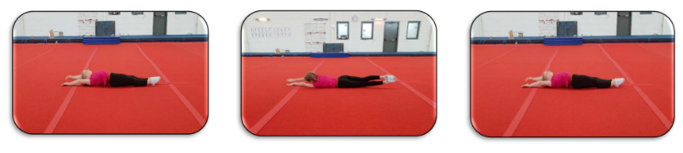  Pencil –Lie on a flat mat with your arms stretched straight over your head and feet stretched away from your body. Roll to in one direction ensuring that the tummy, legs and muscles are squeezed together. Complete a number of rolls until reaching the end of the mat.  Tuck – Kneel on the floor, tuck your knees into your chest and hold your arms tightly to the side of your body. Keep your chin tucked in and shoulders just off the floor. Complete a 360 degree rotation completing a full roll of the body.  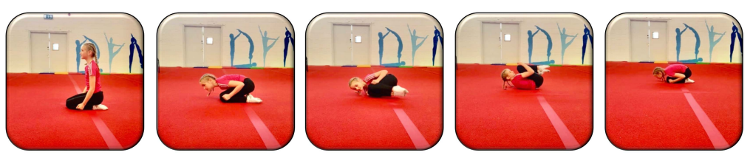  Straddle – Sit on the floor with your legs straight and spread apart. Sitting tall, place your hands behind your knees. Lean to the left bringing the right leg up to start the rolling action. Roll sideways across your back and shoulder finishing back in the straddle position in the opposite direction to where you started. Repeat the roll until you have made a full circle.  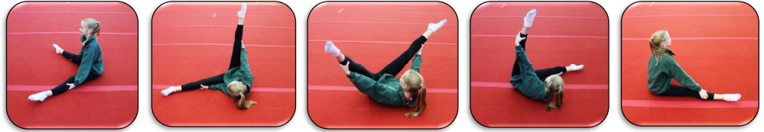  New rolls  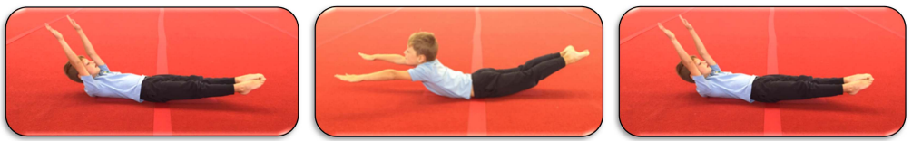  Arched back roll – Lie on the back with the lower back pressed into the mat. Lift the shoulders, arms and legs off the mat making a dish shape keeping them as straight as possible. Turn the head, look under the arm to initiate the roll. Roll over maintaining the arched position. Keep arms and legs off the ground and roll back into starting position.  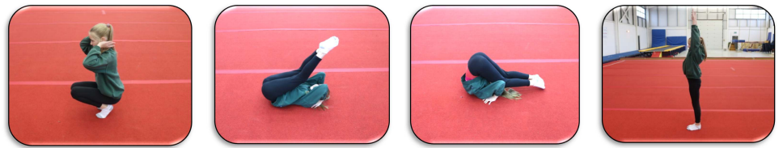  Backward roll – Sit at the edge of the mat facing away with the knees tucked in and feet close to the bottom. Place the hands on the shoulders with palms facing up. Rock backwards onto the back so that the hands make contact with the mat. In one motion, bring the feet over the head lifting the hips and pressing the hands onto the mat, rolling over onto the feet. | EY- Types of rolls taught are egg roll, teddy bear roll, dish roll and rock on back  KS1- Rolling across the mat, pencil and forward roll.
Jumps | Children will learn a range of jumps. | - Children to jump from a bench/ height and show control on landing. Children will recap the jumps taught in KS1/ LKS2 and then focus on 2 new jumps.  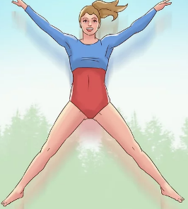  Jumps taught in LKS2  - Star jump – stand with legs shoulder width apart and knees slightly bent. Squat down bending the knees and jump vertically as high as possible. At the same time, bring the arms and legs up to point out wide creating the ‘star’ shape. On the descent, bring the arms and legs back in and land with the knees bent.  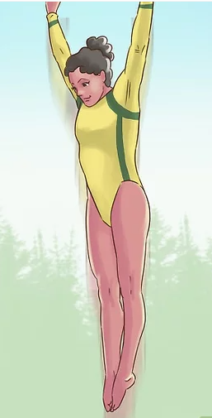  - Straight jump – stand in the straight body position keeping the legs together and arms by the side. Jump straight up and as you enter mid-air, point the toes and extend the arms up past the head pointing fingers. Land in plié position.  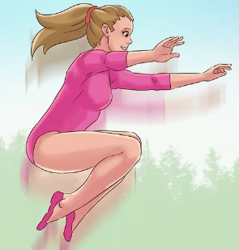  - Tuck jump – stand with feet shoulder width apart keeping the knees slightly bent. Ensure the head is up and eyes facing forward. From the squat position, push up as powerfully as possible and as you reach mid-air, bring the knees into the chest. Bring the arms around to clasp the knees and on decent, let go of the knees and bend on landing.  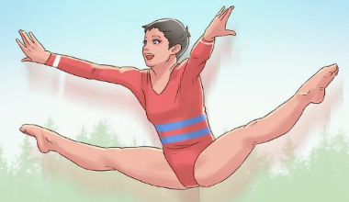  - Straddle jump – To take off, use the strength in your legs to get as high as possible. Bring your legs out and point the toes when in mid-air. Arms should also be stretched out towards the pointed toes (try and touch if possible) keeping the head up with eyes facing forward. On decent, quickly pull the legs back together and bend knees on landing.  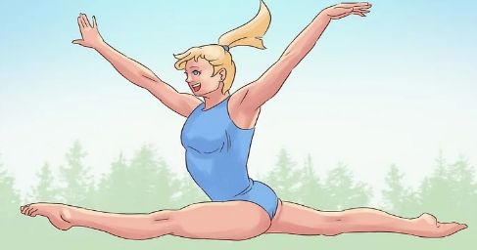  New jumps  - Split jump – Stand with both feet together with arms relaxed. Jump upwards as high as possible and split the legs mid-air with one leg going forwards and the other backwards. When about to land, bring both legs back into the original position and land gently with knees bent.  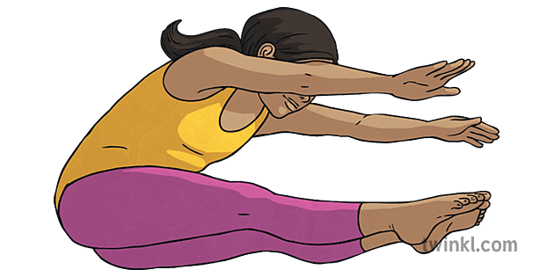  - Pike jump – Stand with feet shoulder width apart. Swing both arms back and squat down by bending knees. Swing arms forward and jump up whilst immediately kicking both legs forward whilst reaching forward to o hand make contact with feet with straight legs. | Previous lesson on jumping in KS1/ LKS2
Supported routine | Children will learn how to mirror a given routine. | - Children will mirror a basic routine including traveling across a mat, rolling and jumping from a bench with control of their body.  Children to complete MTYT in learning a basic routine. Children to be able to name each movement that they are completing. The routine will include:  - Start position  - Two ways of travelling across the mat  - Two rolls  - Two jumps  - End position | Start/ end position, travelling, rolls, jumps.
Independent routine | Children to create their own routine | - Children to create their own gymnastics routine including: start/ end position, travels, rolls and jumps.  Children to be given time to plan their own routine which must include:  - Start position  - Two ways of travelling across the mat  - Two rolls  - Two jumps  - End position  Children to perform their routine whilst being able to explain the name of each element. | Start/ end position, travelling, rolls, jumps.  Supported routine in previous lesson.

Keywords
Early Years (Prior learning) |  | Year 1 and 2 (prior learning) |  |  |  | Year 3 and 4 (prior learning) |  | Year 5 and 6 Key words
move | travel | control | jump | mat | star | elegant | star jump | symmetrical | counter balance
copy | over | hold | safely | bench | pike | extension | forward | asymmetrical | fluently
forwards | space | sequence | perform | level | straddle | pointed toes | Pencil | rotation | counter tension
backwards | rock | strength | routine | direction | speed | graceful | technique | synchronisation | stability
sideways | shape | balance | start position | sequence |  | pointed fingers | explore | aesthetics | split jump
egg roll | teddy bear roll | support | end position | pathway |  | pressure | create | progression | pike jump
dish roll | rock on back | travel | apparatus | link |  | tuck jump | contrasting | cannon | arched back roll
 |  | forward roll | equipment | tuck |  | straddle jump | quality | formation | backward roll
 |  |  |  |  |  | straight jump | apparatus | momentum

