Topic | Knowledge - Children will learn | Children will be able to… | Prior Knowledge
Hockey  (3 sessions) | I can hold the hockey stick correctly and can dribble a ball to an end zone.  I can pass and receive a hockey ball.  I can aim for a target. | - Introduction to hockey.  Introduction to the sport of Hockey:  -History  -Rules  A brief rundown of safety. Rules and expectations of students are set out for the next 3 sessions of hockey.  Describe characteristics and parts of the hockey stick.  Students will be split into groups and will practice correct holding technique and move around the room. Introduce a ball and look at dribbling a ball within a given area whilst still following the correct grip technique.  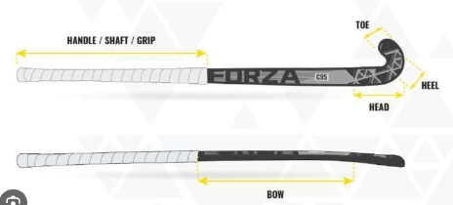  - Pass and receive a hockey ball.  Children to focus on passing and receiving a hockey ball. Children to focus on short passing to begin with and then progress onto how to stop the ball correctly using a hockey stick. Children will then look at improving the distance and speed of pass encouraging them to keep the ball under control at all times and remain within the given area.  - Aim/ shoot a hockey ball towards a target.  Children to focus on aiming for a specific target. Constant reminders on how to hold the hockey stick correctly. Children to take part in a team game where different targets are worth different amounts. Targets will be of different sizes and distances. Children to use their maths knowledge to count their points to share with the rest of the class. | Rolling  Hand/ eye coordination  Target games

Keywords
hockey | shoot | ball
player | goal | team
control | net | stick
dribble | pass | aim
target | receive | safety

Progression of skills
Year 1 | Year 2 | Year 3 | Year 4 | Year 5 | Year 6
 |  | To use a simple push pass to another team mate. |  | To use a simple push pass to another team mate. To begin to use a slap pass to another team mate. To begin to select between the two passes and explain why the pass was chosen.
Dribble the ball within a large playing area. |  | Dribble the ball keeping it close using the correct side of the stick. |  | Use speed to dribble the ball into a space and make a direct pass possibly changing direction.
Begin to attempt to score a goal from anywhere. |  | Attempt to score inside a scoring area. |  | Successfully score whilst inside the scoring area. Seize the opportunity to score quite quickly.

